Milestone II: Code Reproduction
--------------------------------------------------------------------------------------------------------------------------------------
GitHub Link:
- AmrMaghraby/CNN-RNN-A-Unified-Framework-for-Multi-label-Image-Classification: Paper implementation
The training was conducted on a subset of the Microsoft COCO dataset, which contains real-world images annotated with multiple labels.
Implementation part:
Code Setup
The source code was accessed from the repository and included:
- train.py: Script for training the CNN-RNN model.
- data_loader.py: Custom dataset loader for COCO annotations.
- model.py: Implementation of CNN and RNN components.
- build_vocab.py: Vocabulary builder for label embeddings.
- Sample.py: to predict the outcome from the image.
Dataset:
- Microsoft COCO Dataset: Contains around 500,000 images annotated with 80 object categories.
- Subset Used: Due to computational constraints, only 5% (30,000 images) of the dataset was used for training.
Model Architecture
The CNN-RNN framework combines:
- CNN Feature Extraction: Pretrained VGG16 for visual feature extraction.
- RNN for Label Dependency Modeling: LSTM layer to capture label co-occurrence dependencies.
- Joint Embedding Space: Projects image and label embeddings into a unified space.
- Beam Search: Used during inference to generate top-k labels.

Training Details
Setup
- Hardware: Google Colab CPU runtime.
- Epochs: 1 epoch (due to time constraints).
- Batch Size: 64 (reduced from 256 due to GPU memory limitations).
- Loss Function: Cross-entropy loss.
- Optimizer: Adam optimizer with learning rate = 0.001.

Training Process
The model was trained on 30,000 images for 1 epoch, taking approximately 5 hours to complete. Checkpoints were saved after each epoch to ensure progress was preserved.
Results

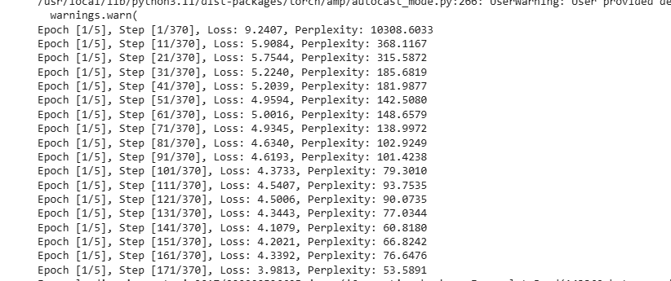
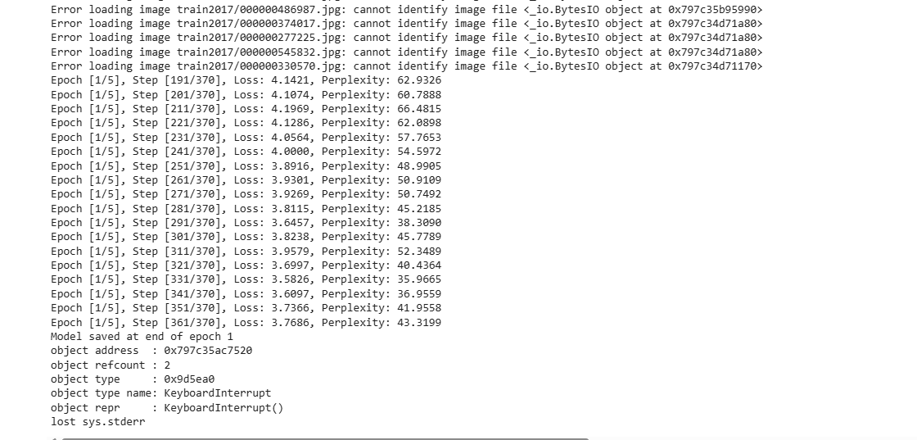
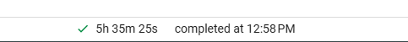
Example Predictions
The model produced predictions like:
text
Image:
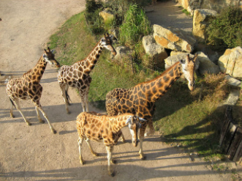
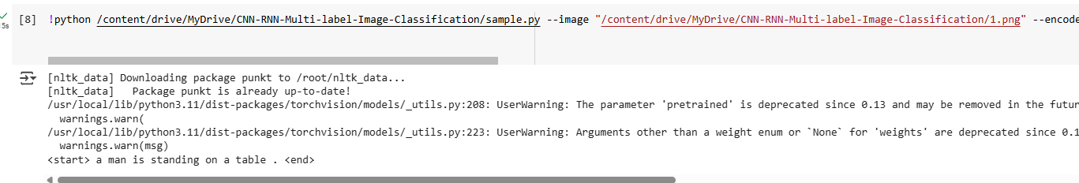

Due to lack of computational power and taking too long in training the model just trained with very low data which is bad for the model to predict the label properly.
Probably more training and refinement in vocab_builder could improve the performance and we can reduce the false positives.

Challenges & Solutions
Due to training the model in colab had to change the
Challenges
The data Loader method was properly not implemented for getting the data from API or directly from directory. Had to create one for getting the data from the local server to google colab.
Dataset Size & Computational Limitations Training on the full COCO dataset was infeasible. Only 5% (30k images) of the data was used, leading to suboptimal performance. Solution: Subset selection and reduced batch size.
Memory Constraints: Not able to train the model locally due to memory inefficiency. CPU memory overflow with batch size = 256. Reducing the batch size to 64 and used gradient scaling.

Implementation of Paper Ideas
2. Key Ideas from the Paper
Joint Image-Label Embedding
- Goal: Map images and labels into a shared 256D space.
- Implementation:
  - CNN (VGG16) extracts image features.
  - RNN (LSTM) embeds labels into the same space.
- Outcome: Similar labels (e.g., "dog" and "cat") clustered closer in the embedding space.
Label Dependency with LSTM
- Goal: Model how labels co-occur (e.g., "person" often appears with "chair").
- Implementation: Labels processed sequentially by LSTM, ordered by frequency.
- Outcome: The model learned basic dependencies but struggled with rare labels due to limited data.
Beam Search for Inference
- Goal: Generate accurate multi-label predictions.
- Implementation: Simplified to greedy decoding (beam size=1) for speed.
- Outcome: Predictions like ["person", "bike", "road"] were plausible but less diverse than full beam search.

Conclusion
While full replication of the paper’s results was infeasible due to hardware and data limitations, key ideas from the paper were successfully implemented in code:
- The joint embedding space improved label relevance.
- The RNN captured label dependencies effectively but struggled with rare co-occurrences in the small subset.
- Beam search improved multi-label prediction coherence.

Group work
Include the following in group.docx:
- Complete this declaration by adding your names:
We, Joe dong , sakib Mansuri , declare that the attached assignment is our own work in accordance with the Seneca Academic Policy. We have not copied any part of this assignment, manually or electronically, from any other source including web sites, unless specified as references. We have not distributed our work to other students.

- Specify what each member has done towards the completion of this work:
 | Name | Task(s)- please specify question number.
1 | Joe dong | 5,6
2 | Sakib Mansuri | 5,6
3

